**Problem No: 01**

**Problem Name:** Solve the equation x^3 - x^2 - 1 = 0 by using Bisection method.

**Objective:** To solve an equation by using Bisection method.

**Source Code:**

#include <iostream>

#include <cmath>

#include <cstdlib>

using namespace std;

double func(double x);

int main()

{

int i;

double f, x1, x, a, b;

cout << "Equation: \nx^3 - x^2 - 1 = 0" << endl;

a = 1;

f = func(1);

for(i = 2; ; i++){

f = func(i);

if(f > 0){

b = i;

break;

}

else

{

a = i;

}

}

x = (a + b) / 2;

while(1){

if((func(a) * func(x)) < 0){

b = x;

}

else if((func(a) * func(x)) > 0){

a = x;

}

else if((func(a) * func(x)) == 0){

break;

}

x1 = (a + b) / 2;

if(abs(x1 - x) <= 0.0001)

break;

x = x1;

}

cout << "Root = " << x1 << endl;

}

double func(double x)

{

double f;

f = pow(x, 3) - x * x - 1;

return f;

}

**Output:** 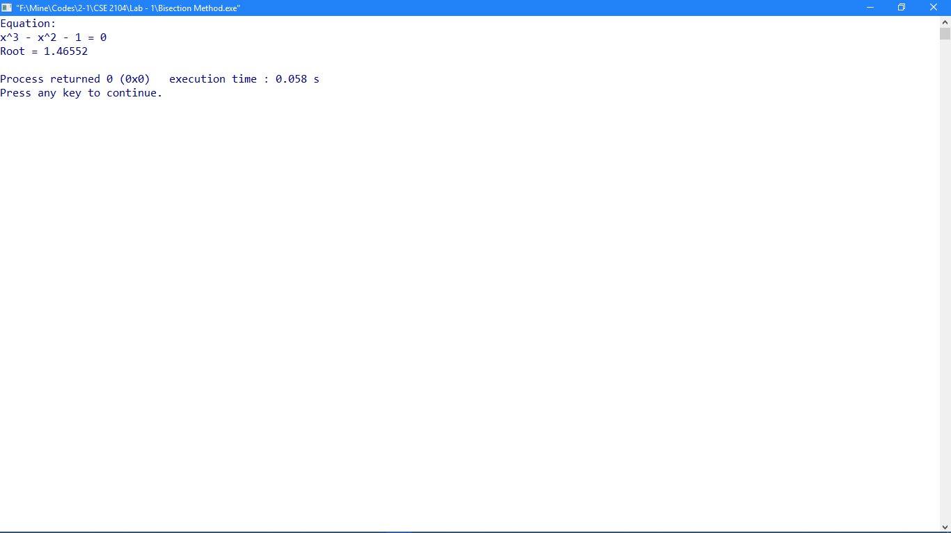

**Problem No:** 02

**Problem Name:** Solve this equation x^3 - x^2 - 1 = 0 by using False Position method.

**Objective:** To solve an equation by using False Position method.

**Source Code:**

#include <iostream>

#include <cmath>

#include <cstdlib>

using namespace std;

double func(double x);

int main()

{

int i;

double f, x1, x, a, b;

cout << "Equation: \nx^3 - x^2 - 1 = 0" << endl;

a = 1;

f = func(1);

for(i = 2; ; i++){

f = func(i);

if(f > 0){

b = i;

break;

}

else{

a = i;

}

}

x = ((a * func(b)) - (b * func(a))) / (func(b) - func(a));

while(1){

if((func(a) * func(x)) < 0){

b = x;

}

else if((func(a) * func(x)) > 0){

a = x;

}

else if((func(a) * func(x)) == 0){

break;

}

x1 = ((a * func(b)) - (b * func(a))) / (func(b) - func(a));

if(abs(x1 - x) <= 0.0001)

break;

x = x1;

}

cout << "Root = " << x1 << endl;

}

double func(double x)

{

double f;

f = pow(x, 3) - x * x - 1;

return f;

}

**Output:**

